Guided Capstone Project Report

## Introduction

This report presents the findings and recommendations for the Big Mountain Resort based on a comprehensive analysis. The analysis considered various factors, including resort features, price positioning and revenue impact. The goal of this report is to provide data-driven insights and revised recommendations to optimize Big Mountain Resort operations and profitability.

1. Dataset

The data set used for the analysis contains information about various ski resorts, including Big Mountain Resort. It Includes Numerical and categorical features such as vertical drop, snow-making area, total chairs, fast quads, runs, longest run, trams and skiable terrain. The dataset also provides information about other ski resorts across different regions and states.

1. Key findings

3.1 Resort Features

* Big Mountain Resort stands out in terms of vertical drop, offering a significant advantage over other resorts.
* The resort excels in snow-making area, ranking very high. This factor will provide favorable snow conditions throughout the season.
* The Resort has a large number of total chairs, positioning well above the majority of resorts.
* The number of fast quads at Big Mountain Resort is higher than most resorts.
* In terms of the number of runs, Big Mountain Resort compares favorably to many resorts.
* The resort has one of the longest runs among all resorts.
* Trams are not standard in the resorts, including our resort.
* The Big Mountain Resort has a substantial skiable terrain, positioning it among resorts with a large amount of terrain.

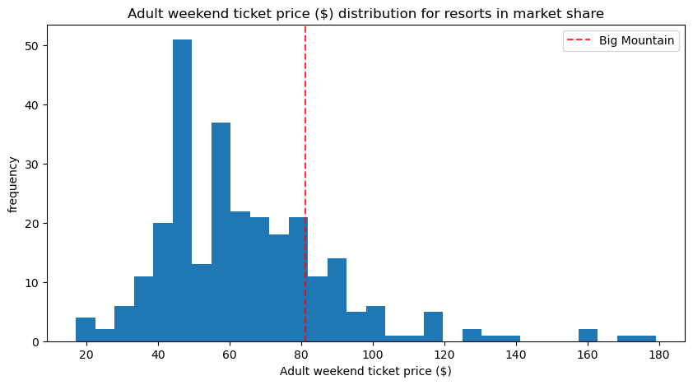

3.2 Price Positioning

The recommendation centers around the implementation of variable ticket pricing. Currently, the resort ticket pricing operates on a fixed structure, regardless of the time of the year or occupancy rate of the resort.

Certain periods of the year attract more visitors, typically around holidays or weekends and the peak of the snowfall periods. There is an opportunity to increase the price without impacting demand significantly. During off-peak times when numbers of visitors are typically lower, I suggest lowering ticket price slightly to increase visitation during these periods. This structure would allow to maximize revenue throughout the year.

.

3.3 Conclusions. Revenue Impact

The analysis of potential scenarios:

* 1. Permanently closing down up to 10 of the least used runs. This doesn't impact any other resort statistics.

*The model says closing one run makes no difference. Closing 2 and 3 successively reduces support for ticket price and so revenue. If Big Mountain closes down 3 runs, Resort may as well close down 4 or 5 as there's no further loss in the ticket price. Increasing the closures down to 6 or more leads to a large drop. (Fig below)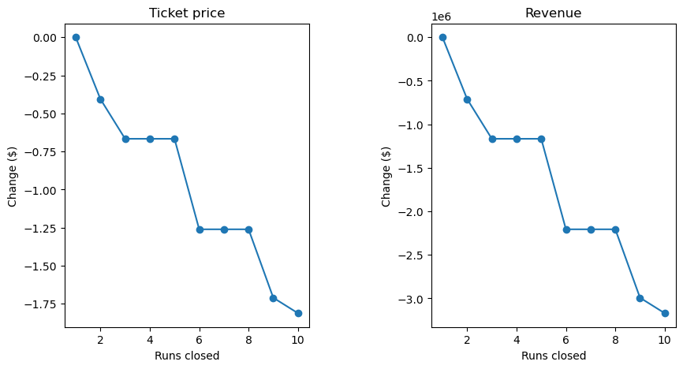*

* 2. Increase the vertical drop by adding a run to a point 150 feet lower down but requiring the installation of an additional chair lift to bring skiers back up, without additional snow-making coverage
* 3. Same as number 2, but adding 2 acres of snow-making cover

*The modeling results for Scenario 2 and Scenario 3:*

*The modeling indicates that Big Mountain Resort could potentially increase the ticket price by $1.99 if they implement Scenario 2 (adding a run, increasing vertical drop by 150 feet, and installing an additional chair lift) or Scenario 3 (same as Scenario 2, but with an additional 2 acres of snow-making coverage).*

* 4. Increase the longest run by 0.2 miles to boast 3.5 miles length, requiring additional snow-making coverage of 4 acres.

*Our model for this Scenario shows no difference in revenue.*

.

This suggests that the market could support a higher price ticket if these improvements are made.